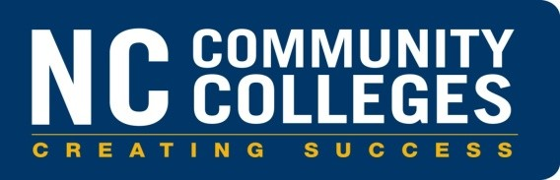

Adult High School Agreement of Affiliation

Contact Information
E-mail: tilleym@nccommunitycolleges.edu

Community College Local Education Agency
The purpose of the Adult High School (AHS) program is to provide a curriculum of instruction that will enable an individual to earn the Adult High School diploma secondary credential. The principles that govern the AHS diploma program were adopted by the North Carolina State Board of Education in December 1992 and by the North Carolina State Board of Community Colleges in January 1993. The following recommendations address the programmatic federal funding updates for adult literacy education and the state policies that govern the operation of an AHS program.

Recommendations:
- The AHS diploma and transcript shall represent the same quality and appearance as issued by the local education agency. The names of both educational agencies shall be listed on the official AHS diploma.
- The minimum number of graduation credits shall be the same as the number adopted by the State Board of Education. Community colleges will follow the graduation requirements as documented in the Future Ready Core graduation requirements; however, NC Department of Public Instruction policy states that high school students may complete the course and credit requirements that were in effect the year they first entered ninth grade, provided that the student was enrolled in a North Carolina high school within the past 5 years.
- The AHS curriculum shall be competency-based, consisting of the core and elective credits required for high school graduation. Electives shall be selected from a variety of program offerings as defined in the local Agreement of Affiliation and structured so that students develop a range of skills which prepare them to succeed in the labor market or to enter technical, vocational, or college transfer programs.
- Students may be granted elective credit for post-secondary courses, military training, apprenticeship programs, business and industry training from which competencies can be documented and evaluated.
- Students may earn up to two core credits based on mastery of competencies demonstrated through challenge exams adopted and evaluated by the local community college.
- A student must earn at least one credit from the community college for an AHS diploma to be awarded.

- While requirements for graduation shall be standardized, instruction may be offered through face-to-face, online, or hybrid and will be determined by the local community college.
- Faculty or instructors who teach AHS courses shall, at a minimum, hold a Bachelor’s Degree and have the knowledge and skills that enable them to meet the needs of adult learners.
- Local community colleges may charge, as appropriate, costs for student textbooks as well as student activity fees and other fees including parking and graduation fees. Charges shall not include fees for registration.
- Community colleges shall maintain permanent records for AHS graduates and provide transcript evaluation services for incoming or returning AHS students. Incoming students are required to provide community colleges with an official high school transcript signed by a principal or administrative designee in order to gain credit for previously earned credits.
- The North Carolina Community College System shall provide an AHS Implementation Guide. This document shall be distributed to the Department of Public Instruction, the community college, and the local education agency.

- The North Carolina Community College System, in cooperation with the Department of Public Instruction,
shall establish a process to:
  - Review Agreements of Affiliation between community colleges and local education agencies every two years on even years (2020, 2022, etc), or when changes occur, for policy and procedural compliance
  - File Agreements of Affiliation with the North Carolina Community College System
  - Maintain a record of AHS graduates by college each program year

Agreement of Affiliation

It is mutually agreed between Community College and the

Board of Education that the policies and recommendations of the State Board of Community Colleges and the State Board of Education which are documented in the Adult High School Implementation Guide shall govern the administration and supervision of the cooperative Adult High School program, students, and instructors. If either party to the agreement wishes to withdraw or alter in any way this cooperative agreement, it is understood that notice of at least four months shall be given to the cooperating agency and that students enrolled in the program at the time of notice shall be given the opportunity to complete the courses for which they are currently registered.

Signature of Superintendent Signature of Community College President

Date: Date:

Signature of Director or Coordinator of AHS Program

Date:

Required Attachment:
Local core course and credit requirements required for the Adult High School diploma

Distribution: The community college will electronically submit the Agreement of Affiliation to the North Carolina Community College System at tilleym@nccommunitycolleges.edu

Copies:
- Cooperating Board of Education
- Cooperating Community College and Board of Trustees

Future-Ready Course of Study (22 credits): Students entering
Grade 9 between 2014-15 and 2019-20
CONTENT AREA | FUTURE-READY CORE  Course of Study Requirements | FUTURE-READY OCCUPATIONAL  Course of Study Requirements
English | 4 Credits  English I, II, III, IV | 4 Credits  English I*, II*, III*, IV*
Mathematics | 4 Credits  Math I, II, III  4th Math Course to be aligned with the student’s post high school plans***  A student, in some circumstances, may have an alternative math course sequence as outlined under State Board of Education policy or due to the transition in standards. | 3 Credits  Introduction to Mathematics Math I*  Financial Management
Science | 3 Credits  A physical science course, Biology, Earth/Environmental Science | 2 Credits Applied Science Biology*
Social Studies | 4 Credits  American History: The Founding Principles, Civics & Economics**  World History  American History I  American History II | 2 Credits American History I American History II
World Languages | Not required for high school graduation. A two-credit minimum is required for admission to a university in the UNC system. | Not required
Health and Physical Education | 1 Credit  Health/Physical Education  Students are required to successfully complete CPR instruction to meet Healthful Living Essential Standards as a requirement for high school graduation.  Accommodations/alternative assessments for students identified by ADA or IDEA will be provided. | 1 Credit  Health/Physical Education

Continued from Previous Page
CONTENT AREA | FUTURE-READY CORE  Course of Study Requirements | FUTURE-READY OCCUPATIONAL  Course of Study Requirements
Electives or other requirements | 6 Credits required  2 elective credits of any combination from either:  - Career and Technical Education (CTE)  - Arts Education  - World Languages  4 elective credits from the following (four-course concentration recommended):  - Career and Technical Education (CTE)  - JROTC  - Arts Education (e.g. dance, music, theater arts, visual arts)  - Any other subject area or cross-disciplinary courses (e.g. social studies, science, mathematics, English, and dual enrollment courses) | 6 Credits  Occupational Preparation I, II, III, IV***** Elective credits  Additional requirements:  - Completion of IEP Objectives  - Career Portfolio
Career/Technical |  | 4 Credits  Career/Technical Education electives
Arts Education (Dance, Music, Theatre Arts, Visual Arts)
Total | 22 Credits plus any local requirements | 22 Credits plus any local requirements
* OCS Pathway courses aligned with North Carolina Standard Course of Study in English I, II, III, IV; Math I and American History I, II, and Biology.
** This course must follow the NCSCOS in its entirety and may not be satisfied by an Advanced Placement (AP), International Baccalaureate (IB) or Cambridge International Examination (CIE) courses, dual enrollment or any other course that does not fully address the NCSCOS.
*** Refer to the North Carolina Mathematics Graduation Requirements Options Charts for the 2020-2021 School Year in attachment B.

Future-Ready Course of Study (22 Credits): Students entering Grade 9 in 2020-2021
CONTENT AREA | FUTURE-READY CORE  Course of  Study Requirements | FUTURE-READY OCCUPATIONAL  Course of  Study Requirements
English | 4 Credits  English I, II, II, IV | 4 Credits  English I, II, III, IV
Mathematics | 4 Credits  NC Math 1, 2, and 3  4th Math Course to be aligned with the student’s post high school plans**  A student, in rare instances, may be able to take an alternative math course sequence as outlined under State Board of Education policy. | 3 Credits  Introduction to Mathematics NC Math I  Financial Management
Science | 3 Credits  A physical science course, Biology, Earth/Environmental Science course | 2 Credits Applied Science Biology
Social Studies | 4 Credits  Founding Principals of the United States of America and North Carolina: Civic Literacy  Economics and Personal Finance  American History  World History | 2 Credits  American History: Founding Principles, Civics & Economics  American History I or American History II
World Languages | Not required for high school graduation. A two-credit minimum is required for admission to a university in the UNC system. | Not required
Health and Physical Education | 1 Credit  Health/Physical Education  Students are required to successfully complete CPR instruction to meet Healthful Living Essential Standards as a requirement for high school graduation.  Accommodations/alternative assessments for students identified by ADA or IDEA will be provided. | 1 Credit  Health/Physical Education  Students are required to successfully complete CPR instruction to meet Healthful Living Essential Standards as a requirement for high school graduation.  Accommodations/alternative assessments for students identified by ADA or IDEA will be provided.

Continued from Previous Page
CONTENT AREA | FUTURE-READY CORE Course of  Study Requirements | FUTURE-READY OCCUPATIONAL  Course of Study Requirements
Electives or other | 6 Credits | 6 Occupational Preparation Credits:
requirements | 2 Elective credits of any combination from either:
 | - Career and Technical Education (CTE)  - Arts Education  - World Languages  4 Elective credits from the following (four-course concentration recommended) | Preparation I, II, III, IV*  Elective credits  Additional requirements:  - Completion of IEP Objectives  - Career Portfolio
 | – Career and Technical Education (CTE)
 | – JROTC
 | – Arts Education (e.g. dance, music, theater arts, visual arts)
 | – Any other subject area (e.g. social studies, science, mathematics, English)
Career/Technical |  | 4 Credits  Career/Technical Education electives
Arts Education (Dance, Music, Theatre Arts, Visual Arts)
Total | 22 Credits plus any local requirements | 22 Credits plus any local requirements
*Completion of 150 hours of school-based training with work activities and experiences that align with student’s post-school goals, 225 hours of community-based training, and 225 hours of paid employment or 225 hours of unpaid vocational training, unpaid internship, paid employment at community rehabilitation facilities, and volunteer and/or community service hours.
**Refer to the North Carolina Mathematics Graduation Requirements Options Charts for the 2020-2021 School Year in attachment B.

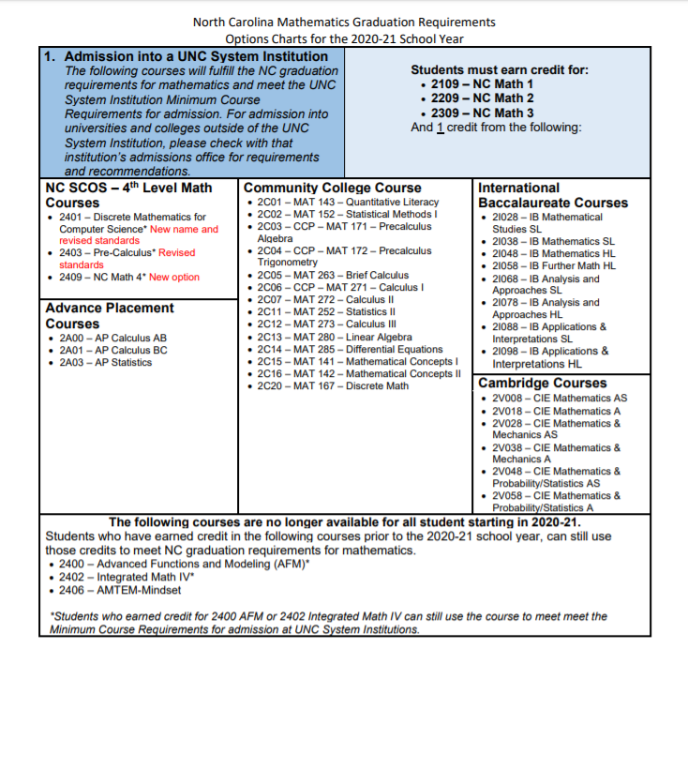

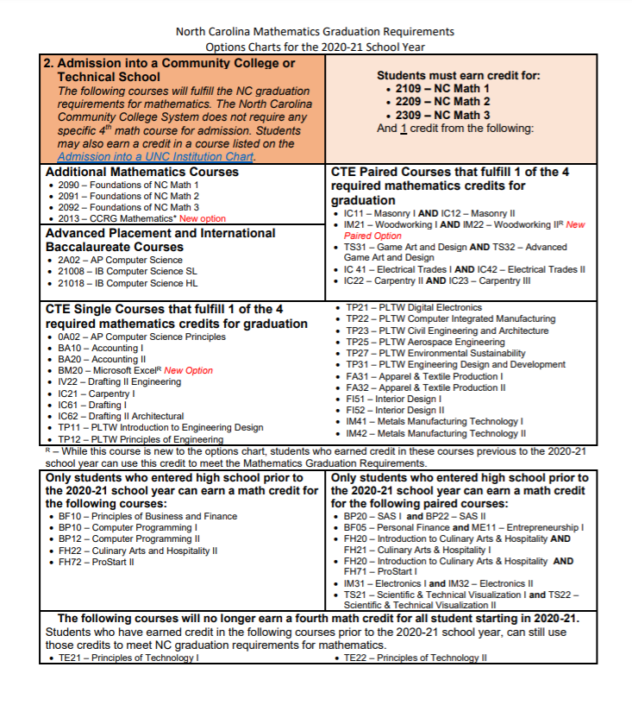

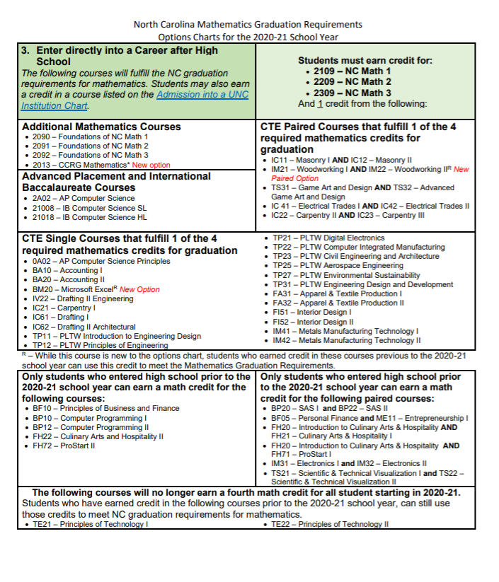
Adult High School – Implementation Guideline

