
Distance Learning Clock Time Software Approval Application

Software Name:________________________________________________________
Provider Name:________________________________________________________
Applicant Name:________________________________________________________
Applicant Email Address:_________________________________________________
- Give a brief overview/description of the software:

- In order to be approved, the software must be capable of generating a Time-Stamped Student Login-Logout Report similar to this:
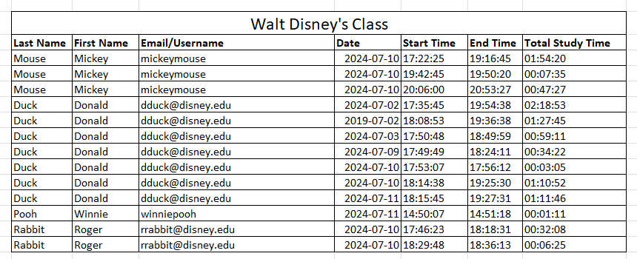
- Does the software have a feature that generates a Time-Stamped Student Login-Logout Report similar to the example above?____________________________

- Attach an example copy of the Time-Stamped Student Login-Logout Report that the software generates.

- After how many minutes of inactivity will the software log off an inactive student? ________________________________________________________________

- Please submit documentation from the publisher on the minutes of inactivity before a student is logged off.

Once you have completed this application form, email these three things to Daniel Loges at logesd@nccommunitycolleges.edu
- This Application Approval Form
- An example Time-Stamped Student Login-Logout Report from the software
- Documentation from the publisher on the minutes of inactivity before a student is logged off.

